Q1: What is a Naïve Bayes Classifier?

Q2: Why Naive Bayes is called Naive?

Q3: How does the Naive Bayes classifier work?

Q4: How would you use Naive Bayes classifier for categorical features? What if some features are numerical?

Q5: What are some disadvantages of using Naive Bayes Algorithm?

Q6: What are some advantages of using Naive Bayes Algorithm?

Q7: Compare Naive Bayes vs with Logistic Regression to solve classification problems

Q8: 4 Applications of Naive Bayes Algorithms

Q1: What is a Naïve Bayes Classifier?
- Naive Bayes Classifiers are a family of simple probabilistic classifiers based on applying Bayes' theorem with strong independence assumptions between the features.
- Bayes' theorem is given by the following equation
- P(A∣B)=P(B∣A)P(A)/ P(B)
- Using Bayes' theorem, the probability of A happening given that B has occurred can be found.
- An example of the way a Naive Bayes Classifier can be used is, given that it has rained, the probability of temperature being low is P(Temperature|Rain).
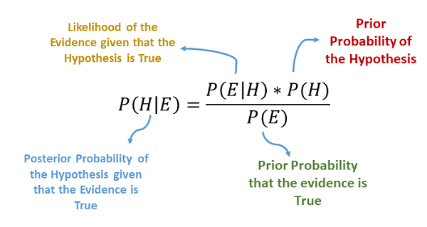

Q2: Why Naive Bayes is called Naive?
We call it naive because its assumptions (it assumes that all of the features in the dataset are equally important and independent) are really optimistic and rarely true in most real-world applications:
- we consider that these predictors are independent
- we consider that all the predictors have an equal effect on the outcome (like the day being windy does not have more importance in deciding to play golf or not)

Q3: How does the Naive Bayes classifier work?
Naive Bayes methods work by applying Bayes’ theorem with the “naive” assumption of conditional independence between every pair of features given the value of the class variable.
The Bayes’ theorem states that for a given class variable y and dependent feature vector x = x_1 + x_2 .+ ….x_n
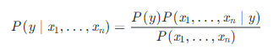
We can simplify the above expression using the naive assumption that features of measurement are independent of each other, i.e.
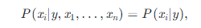
Which lead to:
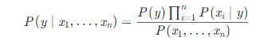
Since, P(x1,…,xn) is constant given the input, we use Maximum A Posteriori (MAP) estimation to estimate P(y) P(y) and P(x_i \mid y)P(xi∣y), which results in
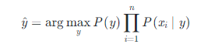
This calculation can be performed for each of the class labels, and the label with the largest probability can be selected as the classification for the given instance.
The different Naive Bayes classifiers differ mainly by the assumptions they make regarding the distribution of
P(x_i \mid y)
P(xi|y).

Q4: How would you use the Naive Bayes classifier for categorical features? What if some features are numerical?
We can use any kind of predictor in a Naive Bayes classifier. All we need is the conditional probability of a feature given the class, i.e., P(F | Class).
- For the categorical features, we can estimate P(F | Class) using a distribution such as multinomial or Bernoulli.
- For the numerical features, we can estimate P(F | Class) using a distribution such as Normal or Gaussian.
- For a numerical feature that follows a different specific distribution, for example, an exponential, then that specific distribution may be used instead.
- For a numerical or categorical without a well-defined distribution, then a kernel density estimator can be used to estimate the probability distribution instead.
Since Naive Bayes assumes the conditional independence of the features, it can use different types of features together. We can calculate each feature’s conditional probability and multiply them to get the final prediction.

Q5: What are some disadvantages of using Naive Bayes Algorithm?
Some disadvantages of using Naive Bayes Algorithm are:
- It relies on a very big assumption that the independent variables are not related to each other.
- It is generally not suitable for datasets with large numbers of numerical attributes.
- It has been observed that if a rare case is not in the training dataset but is in the testing dataset, then it will most definitely be wrong.

Q6: What are some advantages of using Naive Bayes Algorithm?
Some advantages of using Naive Bayes algorithm are:
- It is a simple, fast, and very robust method of classification.
- It does well with both clean and noisy data.
- It requires a few examples for training, but the underlying assumption is that the training dataset is a true representative of the population.
- It is easy to get the probability for a prediction.

Q7: Compare Naive Bayes vs with Logistic Regression to solve classification problems.
Naive Bayes assumes conditional independence among the features, which is not true in most real-life problems. So then, if for a problem these assumptions are not satisfied, the Logistic Regression model would be less biased and therefore, it will outperform Naive Bayes when given lots of training data.
Naive Bayes has a time complexity of O(log n), whereas the logistic regression is O(n). So, for n number of features, Naive Bayes converges more quickly to its asymptotic estimates. Hence, it will outperform Logistic Regression in the case of a small training dataset.

Q8: 4 Applications of Naive Bayes Algorithms.
As you must’ve noticed, this algorithm offers plenty of advantages to its users. That’s why it has a lot of applications in various sectors too. Here are some applications of Naive Bayes algorithm:
- As this algorithm is fast and efficient, you can use it to make real-time predictions.
- This algorithm is popular for multi-class predictions. You can find the probability of multiple target classes easily by using this algorithm.
- Email services (like Gmail) use this algorithm to figure out whether an email is a spam or not. This algorithm is excellent for spam filtering.
- Its assumption of feature independence, and its effectiveness in solving multi-class problems, makes it perfect for performing Sentiment Analysis. Sentiment Analysis refers to the identification of positive or negative sentiments of a target group (customers, audience, etc.)
- Collaborative Filtering and the Naive Bayes algorithm work together to build recommendation systems. These systems use data mining and machine learning to predict if the user would like a particular resource or not.

